FACULTY EVALUATION
Programme Name: Resource Mobilization Programme
Session: Proposal development: Understanding donor requirements and donor approaches to proposal development
Faculty Name: Leone Mawa
No. of Respondents: 9
No. of Participants: 10
Evaluation Parameter | (%) Individual Score | (%) Programme Average
Punctuality | 91 | 96
Clarity of presentation | 87 | 94
Degree of preparation | 91 | 94
Course design & org | 89 | 91
Content & methodology | 87 | 93
Quality of discussions | 87 | 94
Relevance to work | 93 | 95
Average scores | 89 | 94

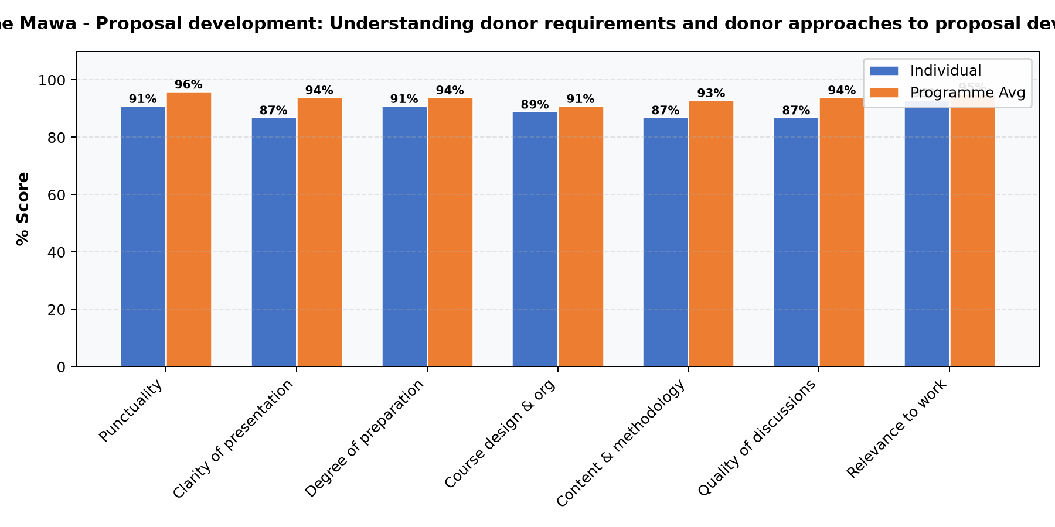

Comments & Feedback
No comments recorded.
SUBMITTED THROUGH:
NAME: ______________________ SIGN: ______________________ DATE: ______________________

